**VA Fingerprinting and Badging Procedures**

All Health Professions Trainees are issued some type of VA identification badge before they start their VA clinical rotations. All trainees are issued a VA Personal Identity Verification (PIV) card after completion of fingerprint screening and VHA Mandatory Training for Trainees (MTT).

Fingerprint Appointments: Trainees can schedule appointments for fingerprinting at Kansas City VA Medical Center (KCVAMC) via the PIV scheduling Tool (<https://va-piv.com/>). ***Please be sure to bring in 1 form of ID with your SSN card when fingerprinting (i.e. driver’s license, passport, any government issued ID).*** All forms of ID must be valid and cannot be photocopies.

Fingerprints are only good for 120 days from the day that you have them done. If you get your fingerprints done more that 120 days prior to the start of your rotation, you will be required to refingerprint.

**KU Med students should fingerprint approx. 30 days out before the start of their rotation and let Scott Sheridan know they are completed**

PIV Badge appointments: Trainees can schedule appointments for a PIV badge **ONLY** after contacting your coordinator at the gaining facility. While at your appointment for your PIV badge you must have **TWO** valid forms of ID, one being your SSN card or ***(i.e. driver’s license, passport, SSN card, any government issued ID)***. *If you have a PIV badge from a previous VA rotation, please contact your coordinator at your gaining VA facility for instructions.*

Trainees can get their VA required fingerprinting completed at any VA facility, as long as you can provide the KCVAMC SOI & SON (see below) numbers to the VA facility that is taking your fingerprints. Below are the SOI and SON numbers to provide for remote/courtesy fingerprinting when you are not having fingerprinting done at the KCVAMC. You should utilize the same PIV scheduling tool above to schedule remote/courtesy fingerprinting.

If you have additional questions regarding the scheduling of fingerprints at the KCVAMC or if you are considering remote finger printing you should contact your VA Residency/Fellowship coordinator or the KCVAMC HR Department (816-861-4700 ext. 52017).

**Location Finder (use this link below to find the nearest VA facility to you for courtesy fingerprinting if not using the Kansas City VA Medical Center)**

<http://vaww.va.gov/directory/guide/home.asp>

**Remote Fingerprinting (Courtesy Fingerprinting at VA facility other than Kansas City VA) The below numbers will be needed by the remote facility:**

SOI- Security Office Identifier: **VAB1**

SON-Submitting Office Number: **1253**

**PIV Scheduling Tool: Click on the below link to schedule your fingerprint or PIV appt. Follow the ppt for step by step instructions to create account and logging in to make appt**

Link: <https://va-piv.com/>



**To schedule an appointment for VA PIV Badge**

Link: <https://va-piv.com/>

Follow Screen Shots below

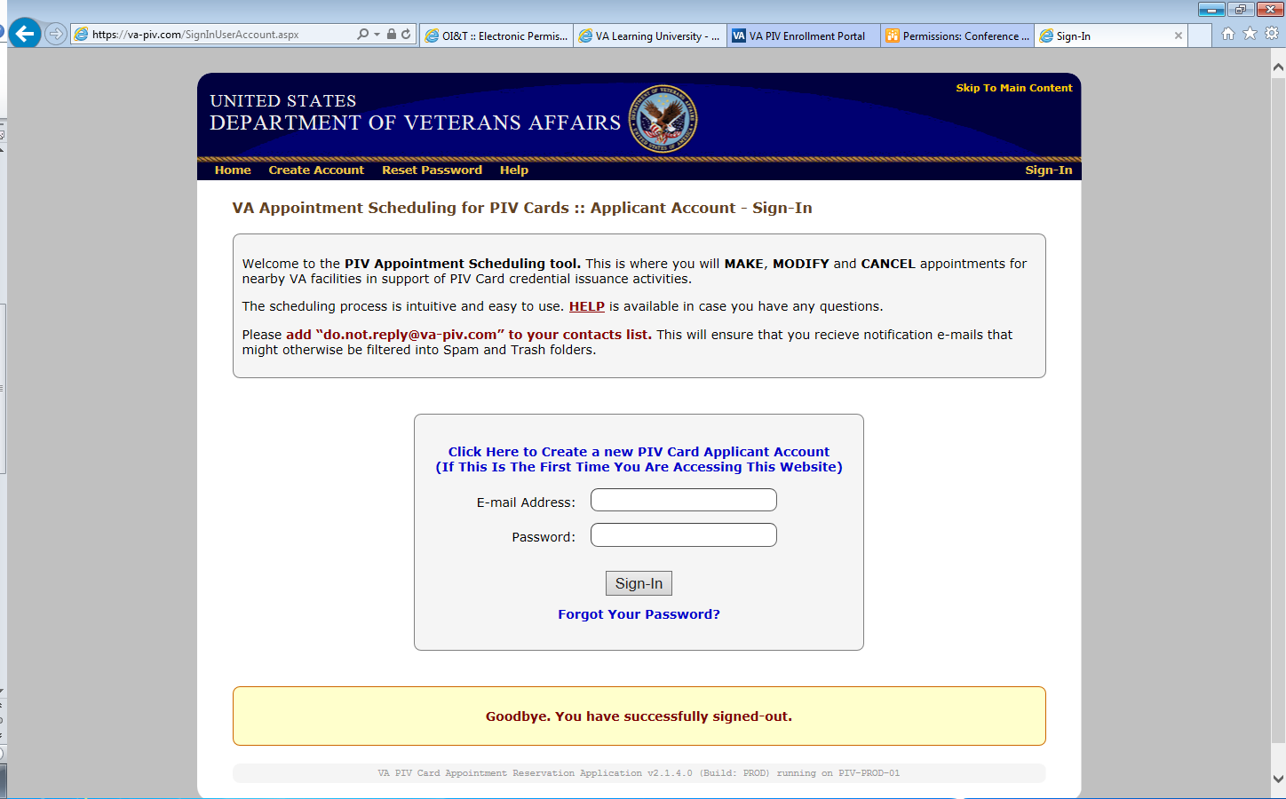

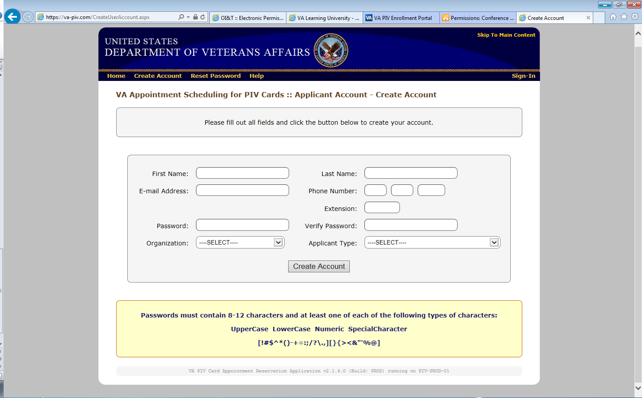

Fill out all the info to create an account. For **ORGANIZATION- VHA.** For **APPLICANT TYPE- AFFILIATE.** Click Create Account

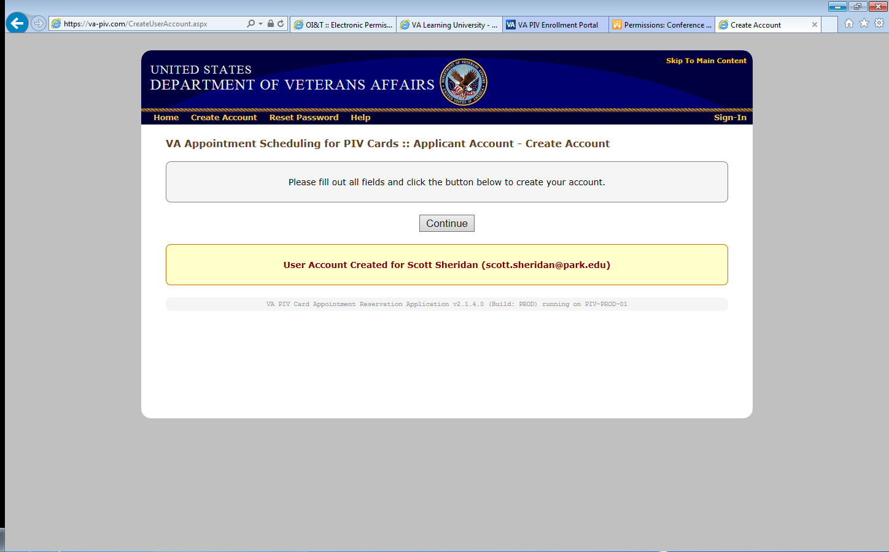

Click continue

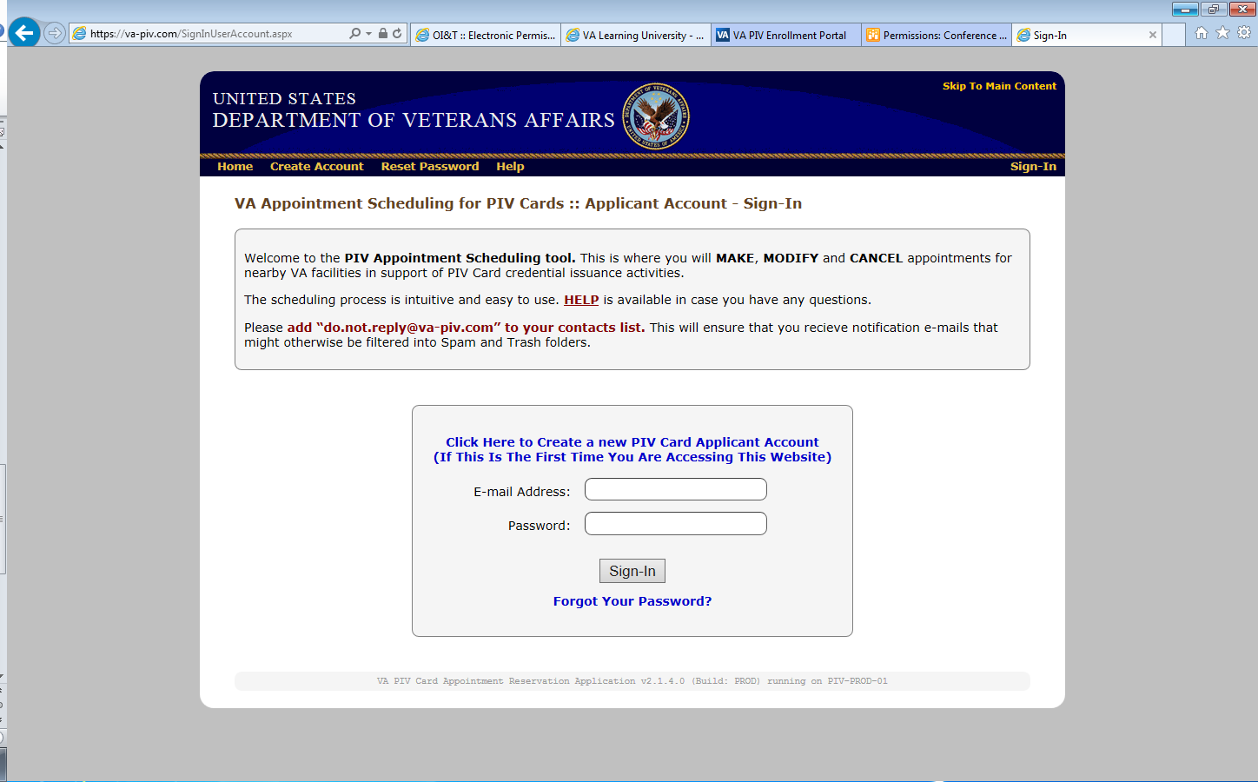

Sign in using the account information you created

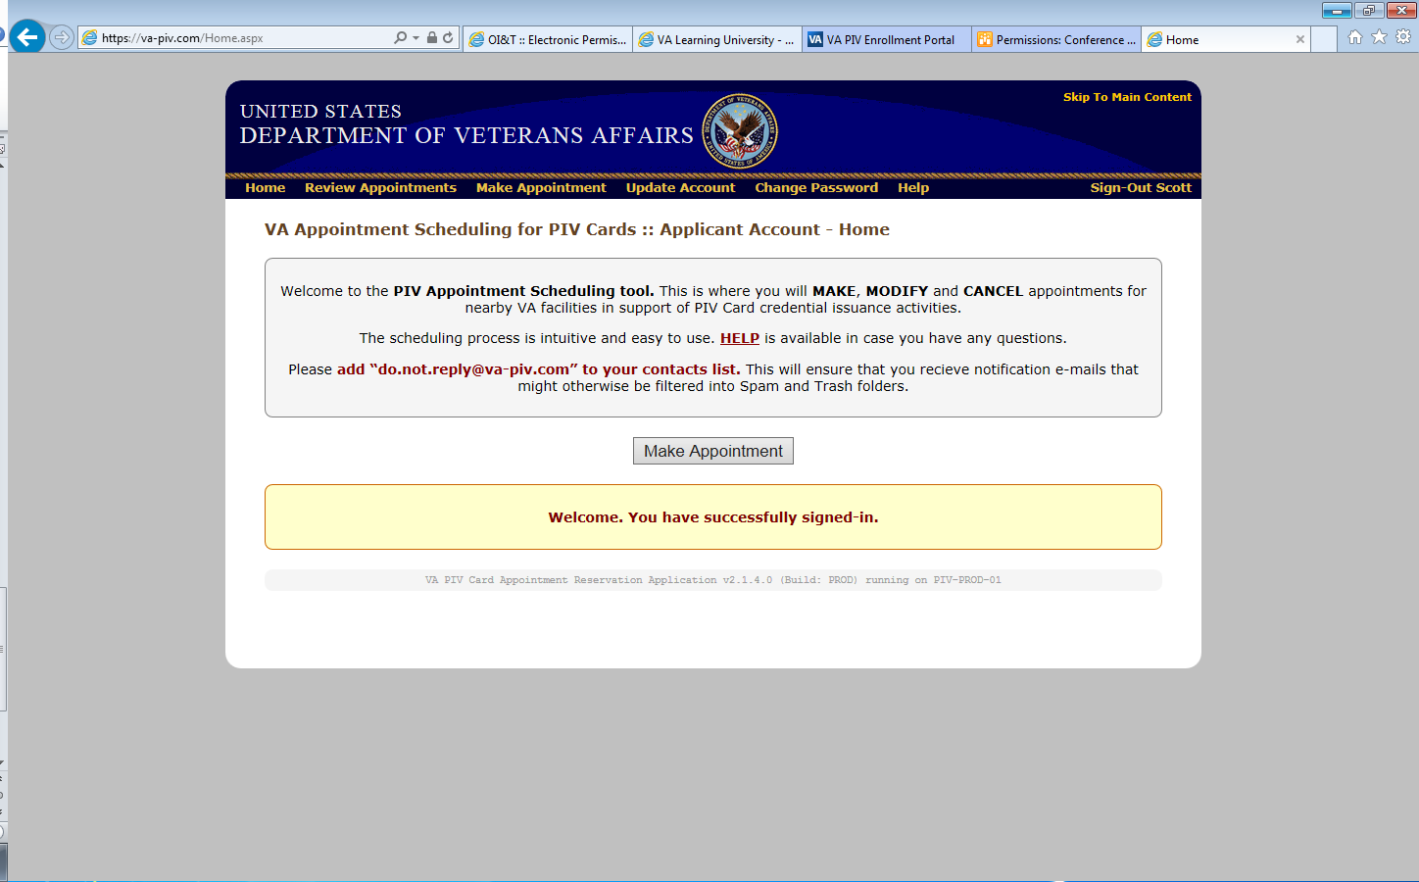

Click on make appointment

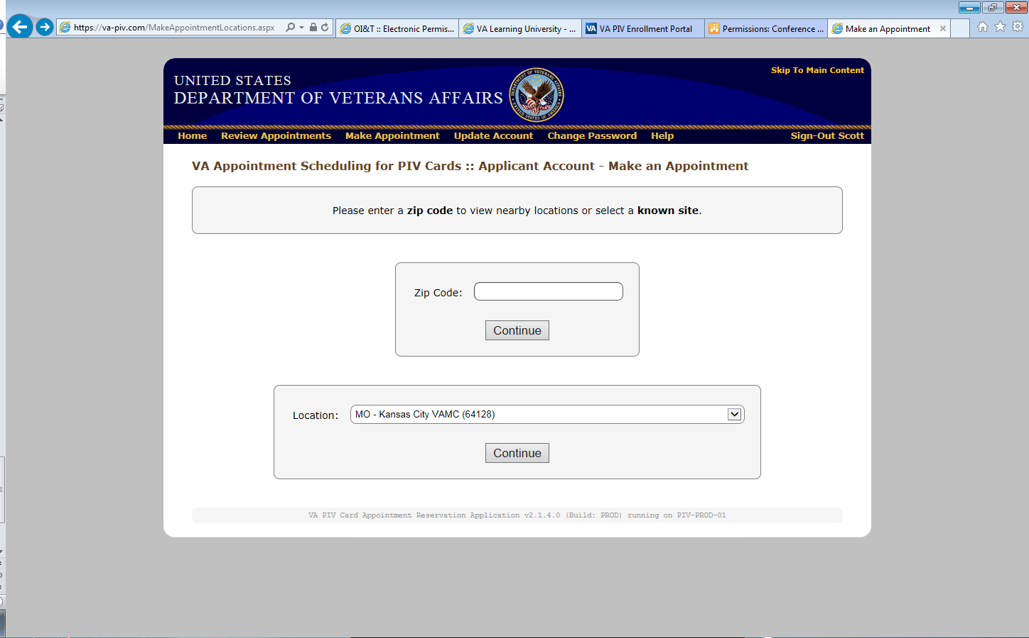

Select MO-Kansas City VAMC (64128) in location drop down menu and click continue

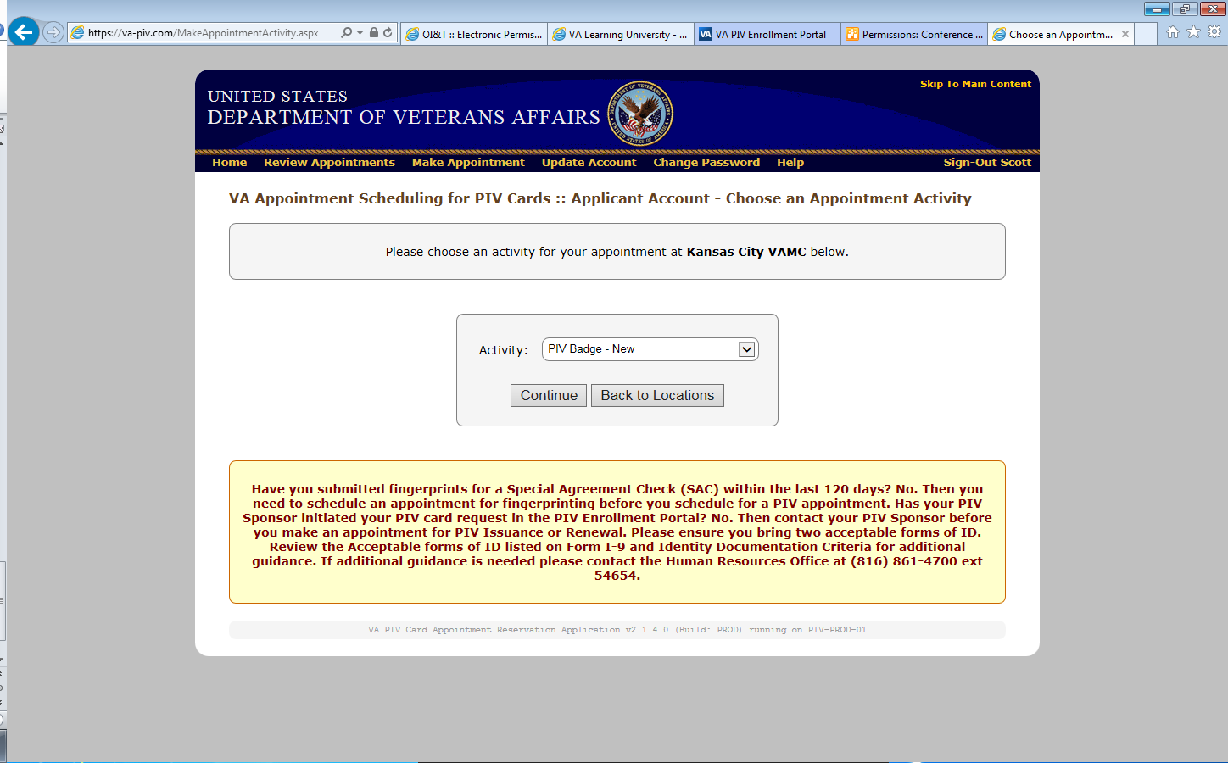

Select PIV Badge-New in Activity drop down menu and click continue

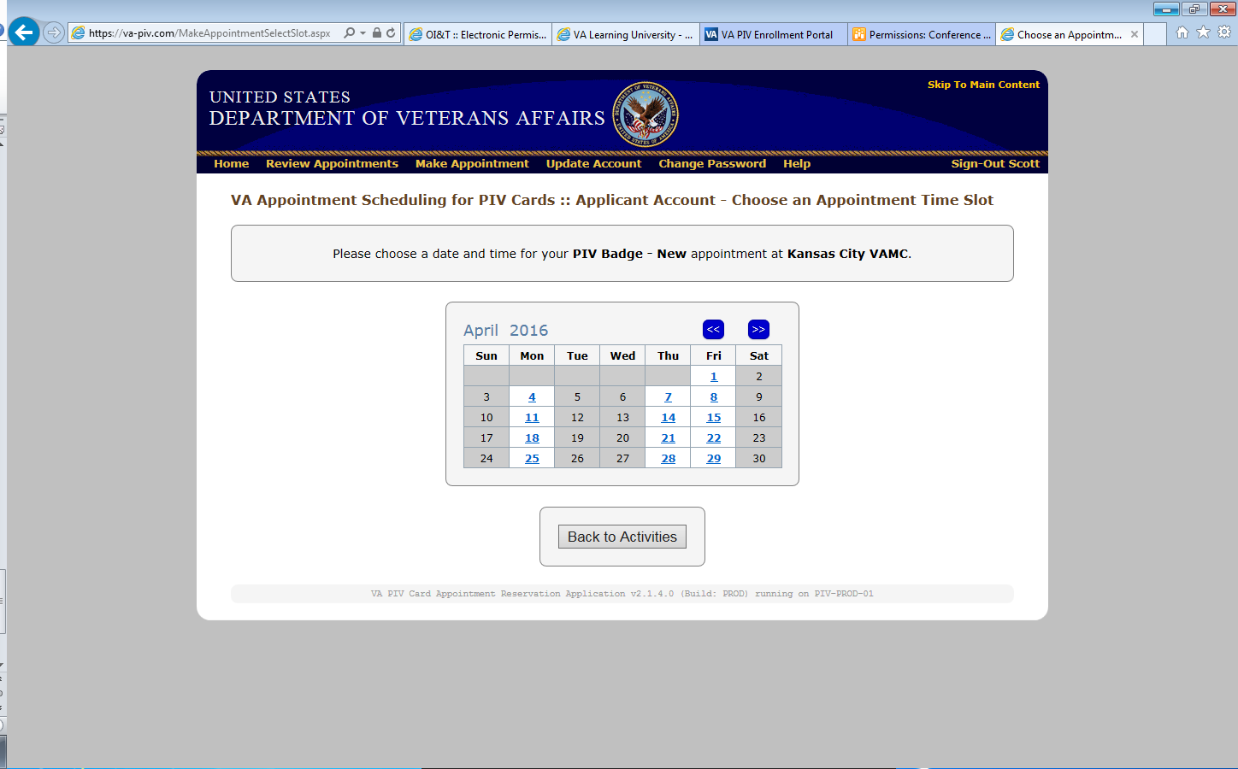

Select date from available dates

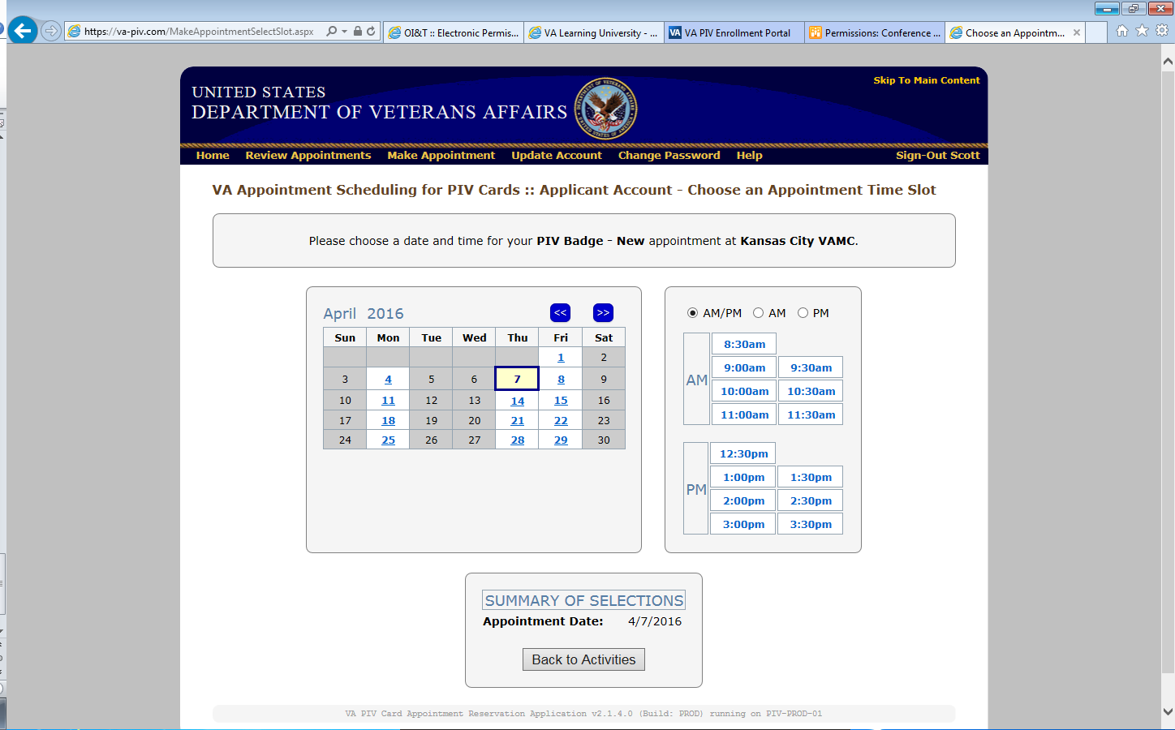

*Select time* and then continue (page will refresh itself to give you continue button)

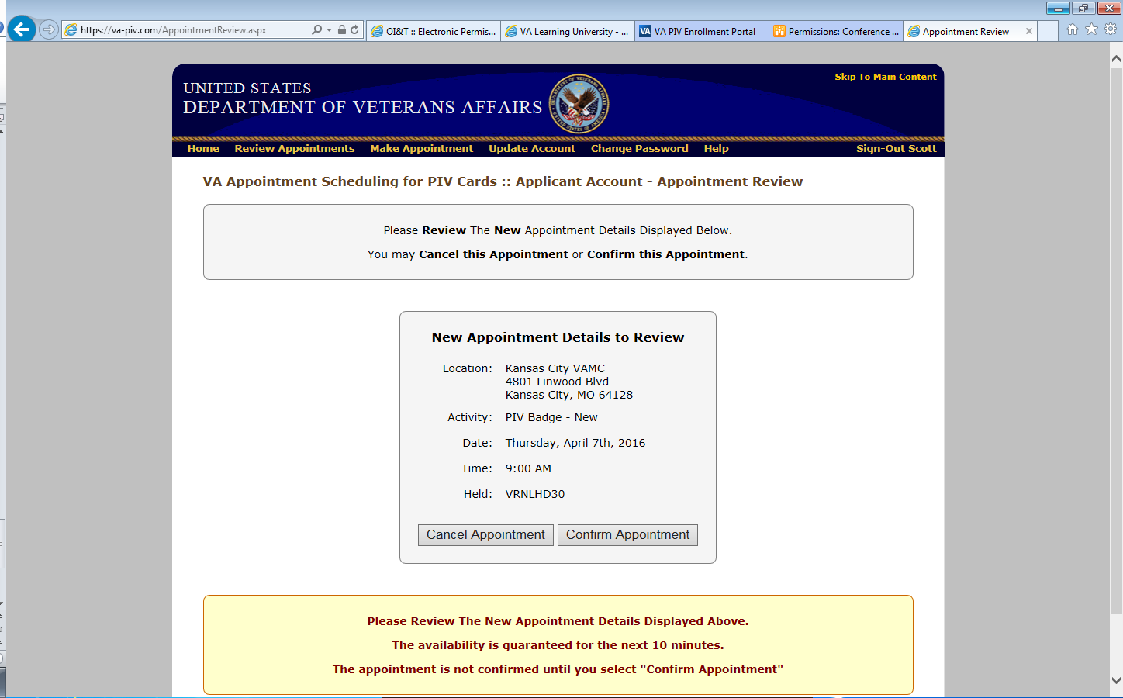

Check your information and either confirm appointment or cancel appointment. Print the screen or write down the “held” code for your records.

** The PIV office is located on the 5th floor, RM 111, Freedom Tower, in the main hospital

** Bring two forms of ID with you. It will take approx. 45 mins to complete the appointment

** Any questions contact your coordinator

**Program Coordinators Phone Number Email**

Psychiatry Scott Sheridan (816) 861-4700 Ext. 52017 [Scott.Sheridan@va.gov](mailto:Scott.Sheridan@va.gov)

Radiology Rachel Brantley (816)861-4700 Ext. 52425 [Rachel.Brantley@va.gov](mailto:Rachel.Brantley@va.gov)

Surgery Scott Sheridan (816) 861-4700 Ext. 52017 [Scott.Sheridan@va.gov](mailto:Scott.Sheridan@va.gov)

Medicine/Medical Subspecialty Scott Sheridan (816) 861-4700 Ext. 52017 [Scott.Sheridan@va.gov](mailto:Scott.Sheridan@va.gov)

Geriatrics Scott Sheridan (816) 861-4700 Ext. 52017 [Scott.Sheridan@va.gov](mailto:Scott.Sheridan@va.gov)

Pathology Scott Simpson (816) 861-4700 Ext. 56150 [Scott.Simpson3@va.gov](mailto:Scott.Simpson3@va.gov)

Education Tech Scott Sheridan (816) 861-4700 Ext. 52017 [Scott.Sheridan@va.gov](mailto:Scott.Sheridan@va.gov)

Designated Education Officer Sharad Mathur M.D. (816) 861-4700 Ext. 52003 [Sharad.Mathur@va.gov](mailto:Sharad.Mathur@va.gov)

**Leavenworth/Topeka VA**

Family Medicine Susan Hoins (913) 682-2000 ext 52446 [susan.hoins@va.gov](mailto:susan.hoins@va.gov)

Kristi Visocsky (913 )682-2000 ext 52142 [kristi.visocsky@va.gov](mailto:kristi.visocsky@va.gov)